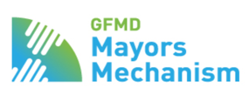

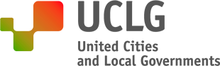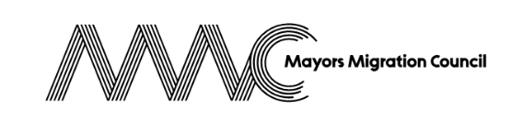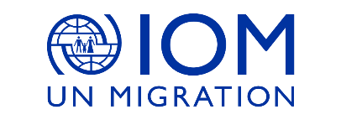
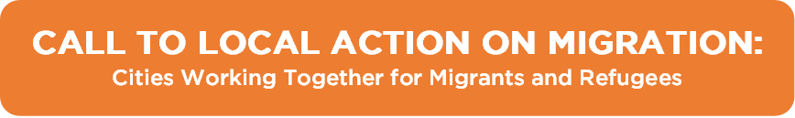

INTRODUCTION

Cities that are committed to advance the implementation of the Global Compact on Migration (GCM) and Global Compact on Refugees (GCR) should use this template to indicate the contribution(s) they would like to pledge in support of the Call to Local Action on Migration launched by the Mayors Mechanism. Please complete this template and send it via email to the following address: mayorsmechanism@gmail.com.

Who can pledge?
A city can pledge individually or with other cities (self-organized or within a city network) through a joint cities’ pledge. Cities can also opt for a joint collaboration pledge with other stakeholders. Pledges should be endorsed by Mayors using the declaration worded as follows “I, Mayor of the City of ____ commit to take the following actions and to report on our progress.”

What is considered as a pledge?
A pledge is a concrete contribution (e.g. an innovative project, policy or program) towards the implementation of the principles and goals of the Global Compacts on Migration and Refugees. Actions started in the past few years that will continue in the next few years are admissible.

When to pledge?
Pledges will be received from October 2019 onwards and in particular prior to and during UCLG World Congress, Global Forum on Refugees and GFMD Mayoral Forum.

What’s next?
The Mayors Mechanism will present pledges and updates on their implementation in the follow-up and review processes of the Global Compacts, including the 2022 International Migration Review Forum (IMRF) and the 2023 Global Refugee Forum (GRF), as well as high-level midterm review meetings, and relevant support platforms. The Mayors Mechanism partners can offer support and advise in preparing the pledge.
PLEDGING ENTITY
Name of City (Country)

Name of Mayor

Name and position of contact person

Email address of the contact person

Telephone number of the contact person

PLEDGE ACTION AREA(S)

Cities and other local authorities are playing an increasing role and undertaking a growing array of responsibilities in addressing the root causes of migration, protecting the rights of migrants and refugees, providing support to migrants and refugees and ensuring their successful inclusion in their communities.

Cities are invited to pledge to implement projects, policies and / or programs towards (any of) the following action areas. These represent only a sample of the type of action that cities are undertaking. They have been selected for their direct relevance to the set of commitments made by cities in the Marrakech Declaration and the role of local authorities in relation to the principles and objectives of the Global Compact for Migration (GCM) and Global Compact on Refugees (GCR). These areas were validated by cities through a consultation process.

Select one or more action areas you would like to pledge:

Action Area 1 – Migration Governance. Improve cities’ internal, vertical and international migration governance. This includes inclusive decision-making, empowered migrants and refugees, and integrated planning across departments, sectors, and levels of government.

Action Area 2 – Economic Opportunity. Promote inclusive growth and the economic integration of migrants and refugees so they can thrive in their host communities and or contribute to the development of their origin cities.

Action Area 3 – Climate Resilience. Increase cities’ resilience to the impacts of climate change and disasters, which disproportionally affect vulnerable migrants and refugees and cause further displacement.

Action Area 4 – Access to Essential Services. Provide migrants and refugees with affordable housing, non-discriminatory access to quality education and health care health services, among other city services regardless of legal status.

Action Area 5 – Inclusion and Social Cohesion. Ensure the participation of migrants and refugees in the political, social, and cultural life of the city. Prevent and combat xenophobia, stereotypes, and misinformation.

Action Area 6 – Vulnerable Groups. Address and reduce the vulnerabilities of the most at-risk groups of migrants and refugees, including women and children, safeguarding their human rights and protecting them against exploitation.

PLEDGE INFORMATION

This section of the template allows you to provide details of the contribution you would like to pledge in support of the Call to Action.

If you would like to announce more than one contribution, please copy and past the entirety of the form below for each.

---

I, Mayor of the City of commit to take the following actions and to report on progress made.

Name of contribution (20 words)
Please give your contribution (project, program, policy) a title of no more than 20 words.

Action Area(s):
Which area(s) is your contribution focusing on?

1 – Migration Governance

2 – Economic Opportunity

3 – Climate Resilience

4 – Access to Essential Services

5 – Inclusion and Social Cohesion

6 – Vulnerable Groups

Description:
What is this contribution about and what are its main objectives? How is this project, policy or program addressing migration and refugee challenges at the local level? How is this intervention creating co-benefits for the host community?

Expected Results:
What are the expected outcomes of this project, policy or program? What metrics are used to track and measure success?

Resources:
What resources (budget, human capital, etc.) have been identified and/or are needed for the design and implementation of this practice?

Timeframe:
Please indicate the anticipated start date and timeframe for follow-up on this contribution.

Partners
Please indicate whether this an individual or joint pledge.

Individual Pledge

Joint pledge

If you are submitting a joint pledge, please indicate key partners involved:

Local authority / city
Please specify:

City network
Please specify:

State/s
Please specify:

International organization
Please specify:

Civil society organization
Please specify:

Private sector
Please specify:

Other
Please specify:

